The Opportunity
Our church is perfectly positioned to welcome and embrace all those in our community who want to share in our vision, mission, and values. We are ready to enlarge and diversify our congregation, bringing more love, hope, and acceptance to those who have felt isolated, alone and unloved. In addition to supporting social justice efforts, we offer our sanctuary to all who seek their chosen spiritual path.

Yet, none of this can happen without your deep support.

The Plan
Our pledge goal of $125,000 is achievable and will continue to keep our church funded and functioning. Please consider increasing your pledge this year if you are able. Your additional generosity will light our way into the future. Increasing your existing pledge by 20%, or increasing your giving by $50, or even $25 per month will go a long way toward our church health and growth.
2023 Pledge Goal - $125,000

Projected Budget Allocation

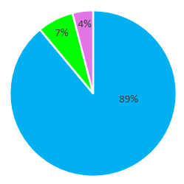
Revenue
89% - Pledges
7% - Non-Pledging Contributions
4% - Fundraising

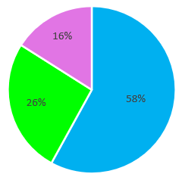
Expenses
58% - Administration
26% - Worship & Programming
16% - Building
Expense notes:
Administrative includes Administrator, Accountant, software, UUA dues
Worship & Program includes Religious Exploration and music staff, and funding for church groups
Building includes mortgage, insurance, utilities, cleaning, and maintenance

How much should I give?
We encourage you to give a percentage of your income (2% to begin with) and to increase that percentage over time toward 5% or more. You can use the Guide to Monthly Giving below to determine your monthly pledge amount.

How do I submit my pledge?
You can fill out the enclosed pledge form and mail it to the church or through the online form at UUCorpus.org/pledge.

Automatic Pledge Payments
If you would like to set up an automatic monthly contribution, fill out the enclosed Electronic Payment Authorization form and mail it to the church. Many find autopayments easier to deal with and budget for. Automated payments substantially ease the burden of administration and help with income predictability for the church as well. Thank you for your commitment to our U2C3 community.
If you have any questions, need paper copies of forms or any other help, please do not hesitate to email us at contact@uucorpus.org or call Lauren Cantatore-Causey (Stewardship Campaign Chair) at 210-831-7820.

2023 Annual Pledge Drive

Unitarian Universalist Church of Corpus Christi

EMBRACING LOVINGKINDNESS is our unique offering to the Coastal Bend Community.

We pledge because we love one another, our chalice and all that it stands for, and the very church where we gather. Every pledge is a deed that honors ourselves, those members who gave us this opportunity, and those who will carry what we value into the future.
We need you to ensure the present health and future flourishing of our church and its mission:
Growing in spirit and faith to inspire radical acts of inclusion, justice, and lovingkindness.

“Generosity is the most natural outward expression of an inner attitude of compassion and loving-kindness.” Dalai Lama

Help Us Spread Our Message

